**Design of the Experiment**

**Between-subjects design:**

**Design**: 3 (*Manipulation*: Bag Info vs. No Bag Info vs. Bag Info [Unrelated]) between-subject design. Method factors counterbalanced across participants:

* + - *Stimulus assignment*: TARGET1/TARGET2 identity assigned to same bag as positive/negative words
    - *Order of evaluative measures*: IAT before vs. after self-reports
    - *IAT block order* (consistent vs. inconsistent with learning phase).

**Stimuli.** Two unknown male images (respectively labelled Chris and James) will serve as TARGET1 and TARGET2. Ten positive (*Fantastic, Wonderful, Honest, Kind, Brave, Amazing, Nice, Pleasant, Selfless, Great*), ten negative adjectives (*Horrible, Nasty, Violent, Terrible, Hated, Disgusting, Mean, Unpleasant, Stupid, Bully*) will serve as Source stimuli.

**Participants.** Data-collection will be via the Prolific website (prolific.achttps://prolific.ac/). We will stop data-collection as soon as 240 participants have completed the experiment on the Prolific website. Recruiting 204 participants will allow us to have good power (> 0.90) to observe a medium EC effect (*f* = 0.25) driven by SOURCE-TARGET bag origin matching, at alpha = 0.05. We decided to collect additional participants in order ensure that the necessary sample size was still obtained after exclusions.

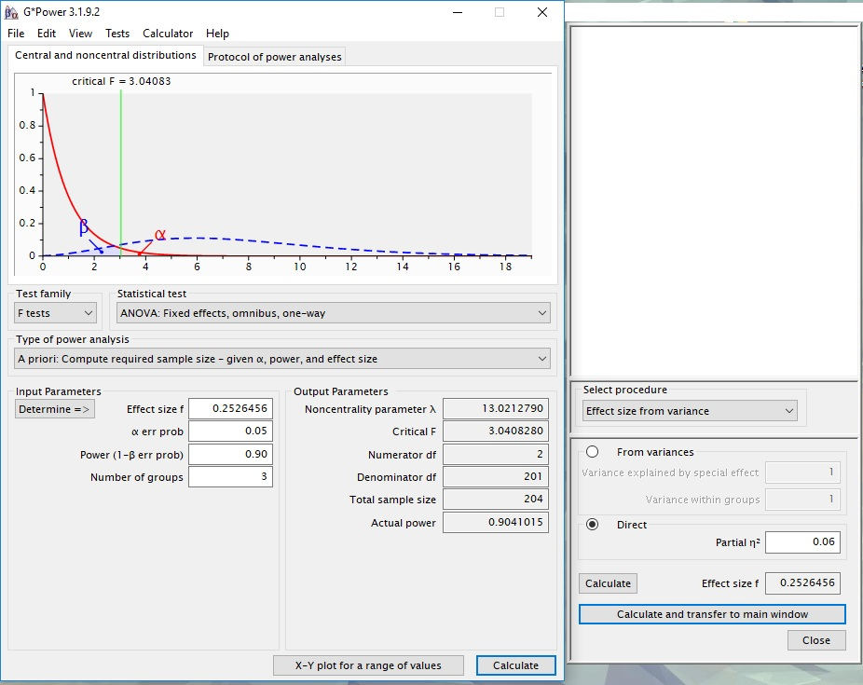

**Procedure.**  *Acquisition phase 🡪 Evaluative measures 🡪 Exploratory Questions*

*Acquisition phase*. Participants receive three blocks of 12 trials (36 total) consisting of four different types of trials: those that presented (a) TARGET1, (b) TARGET2, (c) a positive word, or (d) a negative word. Each trial involved the presentation of the stimulus by itself in the middle of the screen for 4000ms. After each trial a 2000ms intertrial interval was presented where no stimulus appeared on the screen. The order of stimulus presentation was random in order to ensure that there was no contingency between the presentation of one stimulus and another. During each of the aforementioned trial-types, a label was presented above the stimulus indicating from which bag it was pulled. The labels were as follows: “Pulled from Bag 1”, “Pulled from Bag 2”, “Pulled from Bag 3”, “Pulled from Bag 4”, “Pulled from Bag 5”, “Pulled from Bag 6”. The label assignments were varied as a function of block number and stimulus identity. Specifically, TARGET 1 and positive labels were assigned to Bag 1 in block 1, Bag 3, in block 2, and Bag 5 in block 3 whereas TARGET2 and negative words were assigned to Bag 2 in block 1, Bag 4, in block 2, and Bag 6 in block 3. (Note: stimulus identity was counterbalanced across participants).

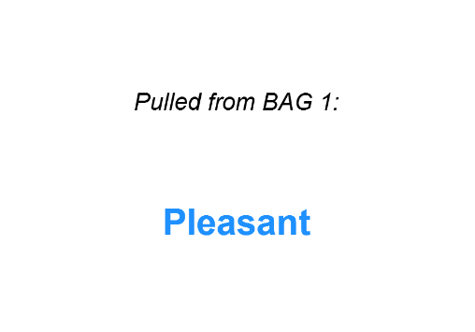 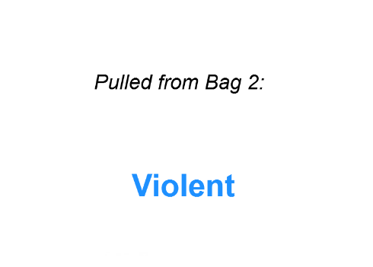

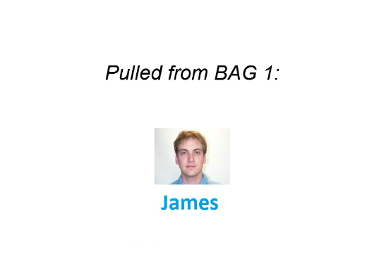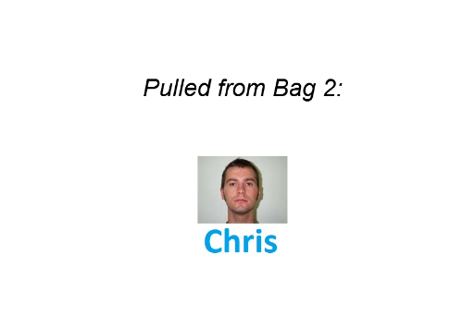

*Figure 1*. Example of the four trial-types encountered during block 1 of the acquisition phase in conditions 1 and 3.

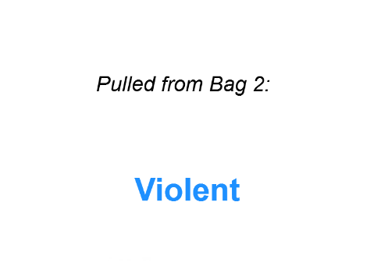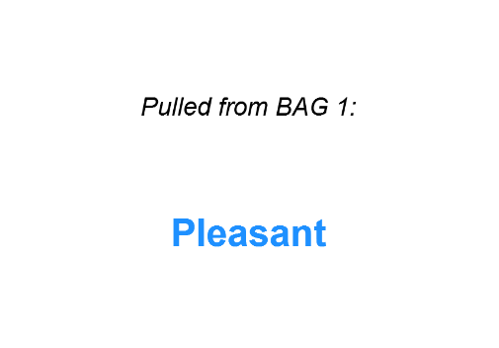

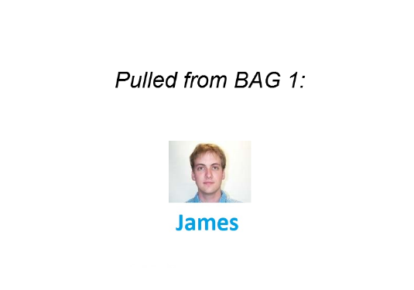

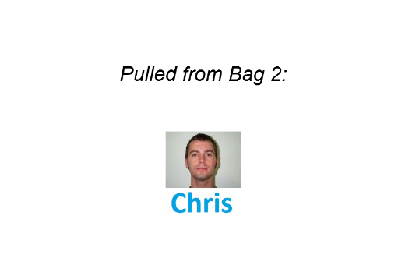

*Figure 2*. Example of the four trial-types encountered during block 1 of the acquisition phase in condition 2.

There are three experimental conditions:

***Condition 1: Bag Info.***This acquisition phase is identical to that outlined above and in Figure 1. Instructions prior to the acquisition phase indicated the following:

“*The computer will now pull a word or image from two bags: Bag 1 & Bag 2.*

*We will tell you what word or image was pulled from Bag 1 or Bag 2.*

*\*\*IMPORTANT: PLEASE PAY ATTENTION TO THE WORDS AND IMAGES PULLED FROM EACH BAG\*\**

*You will be asked questions about this later on.\*\**”

***Condition 2*: *No Bag Info*.** Participants in this condition will receive a similar acquisition phase as outlined above with one notable difference: no bag information will be shown above each stimulus (see Figure 2). Instead stimuli will simply appear onscreen in a random and non-contingent manner.

Instructions prior to the acquisition phase indicated the following:

*“The computer will show you a word or image.*

*PLEASE PAY ATTENTION TO THE WORDS AND IMAGES THAT APPEAR*

*You will be asked questions about these later on.**”*

***Condition 3: Bag Info (Unrelated)*.** This acquisition phase is similar to that outlined in condition 1 with one notable exception. Prior to the acquisition phase participants will be told the following:

“*The computer is going to pull a word or image from two bags: Bag 1 & Bag 2.*

*The computer will tell you what word or image was pulled from Bag 1 or Bag 2.*

*\*\*IMPORTANT: Please pay attention to the words and images that are pulled from both bags. We will ask you questions about this later on.*

*\*\* FINALLY: The contents of each bag were RANDOMLY created. Thus there is no such thing as a 'good' or 'bad' bag, nor is there a connection between the words and images that are pulled from each bag. **”*

In addition participants were required to pass a manipulation check that determined if they fully understood and processed the instructions noted above. If they failed this check they were re-exposed to the instructions once again. Only once they passed the manipulation check were they allowed to continue on to the acquisition phase.

*Automatic evaluations*

Participants will perform an IAT measuring implicit evaluations of TARGET1 vs. TARGET2:   
The IATs involve categories “TARGET1” and “TARGET2” and “Good” and “Bad”  
  
IAT Procedure:

a. Instructions: “In the next part you will have to categorize items into groups as fast as you can.”

b. 20 practice trials sorting TARGET1 on the left and TARGET2 on the right.   
  
c. 20 practice trials sorting positive words on the left and negative words on the right.

d. 20 test trials TARGET1 and positive words Sources using one key and TARGET2 and negative words Sources using another key.

e. 40 test trials TARGET1 and positive words Sources using one key and TARGET2 and negative words Sources using another key.

f. 20 practice trials TARGET2 on the left and TARGET1 on the right.

g. 20 test trials TARGET2 and positive on the left and TARGET1 and negative on the right.

h. 40 test trials TARGET2 and positive on the left and TARGET1 and negative on the right.

NOTE: IAT stimuli are:

* + - TARGET1 (image of Chris)
    - TARGET2 (image of James)

Positive words: *Confident, Loving, Cheerful, Loyal, Generous, Happy, Likeable, Warm*

Negative words: *Liar, Cruel, Evil, Ignorant, Manipulative, Rude, Selfish, Disloyal*

*Self-reported evaluations*. Participants will be shown an image of TARGET1 or TARGET 2 and asked the following questions:

*“Please indicate how you feel about this person*   
options: -5 =Negative, 5= Neutral, +5= Positive

options: -5 =I Dislike him, 5= Neutral, +5= I Like him

options: -5 =Bad, 5= Neutral, +5= Good

options: -5 =Unpleasant, 5= Neutral, +5= Pleasant

*Exploratory questions.* The exploratory questions will largely be the same across the three conditions. However, some items will differ given the variations across conditions. Those items that are similar across conditions are noted first. Those that differ are listed afterwards.

***Similar items across conditions***

*Manipulation check*. “Did you ever take notes (or write down) what happened in order to help you figure out what was going on? Please be honest here (you will receive payment regardless of what you say).”

*Demand Compliance (explicit):* "Earlier you rated Chris and James as being either positive, neutral, or negative. Did you base your response on how you actually felt about those individuals OR on what you thought the researchers wanted you to say?"

How I actually felt about Chris and James", "What I thought the researchers wanted me to say (i.e., not on how I personally felt)", "I don’t know")

*Demand compliance (implicit).* Earlier you completed the Implicit Association Test (see below). Did you base your performance in that task on your best efforts to perform the categorizations as quickly and accurately as possible? Or did you attempt to influence your speed or accuracy in order to go along with what you thought the researchers wanted you to feel about the words?"

("I tried to perform the task as quickly and accurately as possible", "I tried to alter my performance based on what I thought the researchers wanted to find", "I don’t know")

*Reactance. (Explicit).* Earlier you rated Chris and James as being either positive, neutral, or negative. Did you consciously resist what you thought the researchers wanted you to feel about those individuals?"

("Yes", "No", "I don’t know")

*Reactance (implicit).* Earlier you completed the Implicit Association Test (see below). Did you try to influence your speed or accuracy in order to consciously resist what you thought the researchers wanted you to feel about those individuals"

("Yes", "No", "I don’t know")

***Items that differed across conditions***

***Condition 1:***

*US awareness.* "In the beginning of the experiment the computer pulled words and images from two different bags. Did the words that were pulled from the bags...?"

Response options. ("always have a positive meaning", "always have a negative meaning", "have different meanings (e.g., some positive, some negative)", "I don’t remember")

*Shared feature awareness*. "Think back to the first part of the experiment. Chris/JAMES and another word were pulled from the same bag. Was Chris/JAMES pulled from the same bag as...:"

Response options. ("POSITIVE Words", "NEGATIVE Words", "I don’t remember")

*Hypothesis awareness*. In the first part of the experiment we told you that words and images were pulled from two bags. We told you that Chris/James and negative words were pulled from one bag and that James/Chris and positive words were pulled from another bag.

Did you notice that this was happening during the first part of the study? Please be honest here"

Response options. Open-ended.

*Influence awareness*. "Do you think that the fact that Chris/James and negative words were pulled from one bag (and that James/Chris and positive words were pulled from another bag) influenced how much you like or dislike Chris or James? Please be honest here"

Response options. Open-ended.

**Condition 2**:

*US awareness*. "In Part 1 of the experiment the computer showed you a series of words and images. Did the computer show you words that...?"

Response options. ("always had a positive meaning", "always had a negative meaning", "had different meanings (e.g., some positive, some negative)", "I don’t remember")

*Influence awareness.* "Do you think the stream of positive and negative words that were presented along with images of Chris and James in Part 1 of the experiment influenced how much you like or dislike Chris or James? Please be honest here"

Response options. Open-ended.

**Condition 3**:

*Relational information*. "In Part 1 of the experiment we told you about the relationship between the words and images that were pulled from the bags. What did we tell you?"

Response options. ("That the words and images pulled from the two bags were RELATED", "That the words and images pulled from the two bags were UNRELATED", "I don't remember")